EOC Weaknesses!

B1.4 Controlled variables are what many teachers refer to as constants. Be sure students know these terms are synonymous.

B1.3 Graduated cylinders may be marked (calibrated) in different ways. In general, a measuring instrument’s precision is greater when the marks are closer together. Beakers are not used for measuring for that reason.

Ask students to examine the graduates below and determine what the time marks mean. If someone fills the first one to 65ml (there is no 65mL line) there is great room for error—give or take 10mL. If someone fills the last graduate to 6mL, there is less room for error—give or take 1mL.

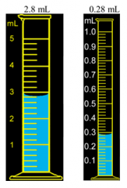
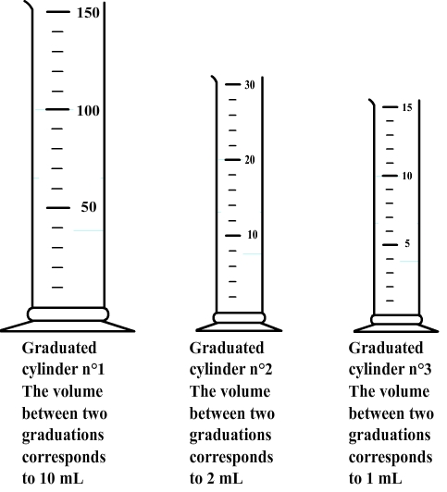

B2.4 Initially cells divide forming a ball of cells that are identical, but they must begin to differentiate into different types of cells.

ZygoteBlastulaGastrula (3 layers of cells: Endoderm, mesoderm, and ectoderm)
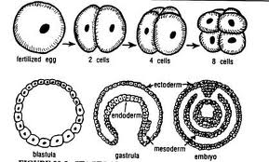
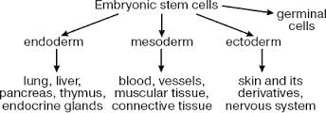

B2.5 Are your students able to make a comparison chart comparing active and passive transport? Do they know which forms of transport are active and which are passive? If told that

Sample: A cell is getting rid of a large worn out organelle. Through which method of transport would this occur?

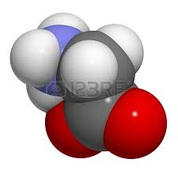
Sample: A skin cell needs more glycine to function normally. Given the size of glycine molecule, through which method of transport would it receive more glycine molecules?

Sample: About 20% of the weight of a muscle cell is oxygen (O₂). How does this much oxygen likely enter the cells?

Video explaining the difference between active and passive transport: http://www.diffen.com/difference/Active_Transport_vs_Passive_Transport

B2.7 Interesting article about cancer cells: http://thebrainbank.scienceblog.com/2013/03/11/cancer-when-good-cells-go-bad/

Check out this skin cancer webquest: http://www.classzone.com/cz/books/bio_07/chapter_home.htm?cin=5

*Refer to section 5.3 in the McDougal-Little textbook.

B3.1 Historical Photosynthesis Expriments: (Priestly, Calvin, Ingenhouz,
http://www.juliantrubin.com/bigten/photosynthesisexperiments.html

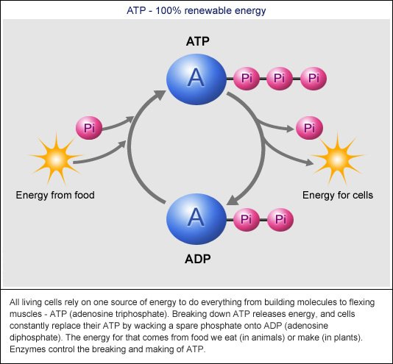
B3.3
ATP Cycle animation:
http://www.dnatube.com/video/3421/ATP-cycle

ATP Cycle from Khan Academy:
https://www.khanacademy.org/test-prep/mcat/biomolecules/overview-metabolism/v/atp

B4.3 and B4.4
Transcription & Translation Animations
http://www.dnalc.org/resources/3d/16-translation-advanced.html

From classzone.com. Click on Build a protein.
http://www.classzone.com/cz/books/bio_07/get_chapter_group.htm?cin=3&ci=8&rg=animated_biology&at=animated_biology&npos=2&spos=8&var=animated_biology

Examples of proteins:
http://examples.yourdictionary.com/examples-of-protein.html

Why does our body need protein? We must eat protein (chicken, fish, nuts, etc.) in order to have the building blocks to make the proteins we need (hormones, amylase, collagen, etc.). When we consume protein our digestive system breaks the bonds between the amino acids so that those amino acids are available in our cytoplasm when the tRNA needs it during translation.

B5.4
Help with defining a species:
*http://evolution.berkeley.edu/evosite/evo101/VSpeciation.shtml

http://www.globalchange.umich.edu/globalchange1/current/lectures/speciation/speciation.html

B5.5 and B5.6
Using Molecular Evidence to show Relatedness:
http://www.pbs.org/wgbh/nova/education/activities/0304_01_nsn.html
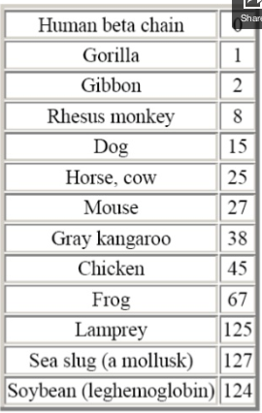
An example of molecular homology:
-The numbers represent the number of amino acid differences between the beta chain of human hemoglobin and the hemoglobins of the other species. In general, the number is inversely proportional to the closeness of kinship.

-All the values listed are for the beta chain except for the last three, in which the distinction between alpha and beta chains does not occur.

-The human beta chain contains 146 amino acid residues, as do most of the others.

Cytochrome C Comparison Lab:
http://teacherweb.com/FL/JohnAFergusonHighSchool/MrBerneBiology/Cytochrome_C_Lab-Student.pdf
B6.2
Abiotic and Biotic Factors Influence upon an Ecosystem
https://www.youtube.com/watch?v=MdlwPtKg-VI

This is pretty good! The link is to p. 1. Look through the next 6 pages. http://www.bbc.co.uk/bitesize/standard/biology/biosphere/investigating_an_ecosystem/revision/1/

B6.4
Nitrogen Fixation
Crash Course: *https://www.youtube.com/watch?v=leHy-Y_8nRs
Chemical Formula for Chlorophyll: C₅₅H₇₂MgN₄O₅

Carbon Cycle: https://www.youtube.com/watch?v=aLuSi_6Ol8M

In this document, sample EOC questions begin on p. 7:
http://ed.sc.gov/agency/programs-services/41/documents/BiologyTeachersGuide.pdf

